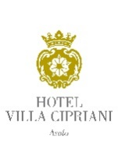

NEW YEAR’S EVE 2025

Purple shrimp carpaccio, Catalonian chicory salad, anchovy mayo and parmesan cheese shavings

Sardinian fregola pasta with clams, porcini mushrooms, clams and langoustine with river watercress coulis

Dover sole fillet a la meuniere with lemon scented crushed potatoes and crispy capers

Passion fruit and mint sorbet

Seared veal fillet, radicchio of Treviso braised in Amarone wine, pomegranate coulis and hazelnut sauce

Cocoa tartlet with chestnut cream, dark chocolate, and pistachio ice cream

Coffee and petit fours

Euro 180,00 per person
Beverage not included

